## What is Tableau

## Tableau Software is an interactive data visualization software company founded on January 2003 by Christian Chabot, Pat Hanrahan and Chris Stolte, in Mountain View, California. The company is currently headquartered in Seattle, Washington, United States focused on business intelligence

***Tableau****is a powerful and fastest growing data visualization tool used in the Business Intelligence Industry. It helps in simplifying raw data into the very easily understandable format. Data analysis is very fast with Tableau and the visualizations created are in the form of dashboards and worksheets.*

## ****Why Tableau?****

Below are some of the pros or features of Tableau which will spellbind you to start using it right away!

**Tableau Features:**

**1. Apt visualizations:**

Tableau connects to many different data sources and can visualize larger data sets than Power BI can. Once in Tableau, a dashboard shows the basics of the users’ data. The user can then drill down into data sets by downloading a worksheet. From there, they can apply various visualizations to the data.

In Tableau, you select the data and switch between visualizations on the fly. It’s easier to jump between visualizations in Tableau.

Tableau visualizes data from the start, allowing you to see the significance right away. Tableau differentiates correlations using color, size, labels and shapes, giving you context as you drill down and explore on a granular level.

**2. Depth of discovery:**

The features of Tableau gives users ways to answer questions as they investigate data visualizations. The solution can show basic trends as predictions, use “what if” queries to adjust data hypothetically, and visualize components of data dynamically for comparisons.

**3. Implementation:**

Tableau provides a variety of implementation and consulting services. For enterprise-level deployment, there’s a four-step process spanning weeks, and for smaller-scale deployments, there are quick-start options that can complete setup in a matter of hours.

Tableau provides a variety of implementation and consulting services. For enterprise-level deployment, there’s a four-step process:

* Phase 1 – This phase involves IT planning, architecture consulting, pre-install checkup, server installation and verification, and validation of security configuration.
* Phase 2 – Phase 2 involves working with data and data migration, including data modeling, data mining, data extraction, data sources and business workflow.
* Phase 3 – In Phase 3, there’s a two-day classroom training covering Tableau Fundamentals, hands-on advanced coaching, and building and formatting visualizations.
* Phase 4 – This final phase helps companies expand Tableau usage across their business. It includes implementation workshops where topics such as evaluating action plans and defining measurable outcomes are discussed.

**4. Automation functionality:**

Tableau is a little more intuitive with creating processes and calculations. For example, when creating calculations in a tabular format, the formula can be typed once, stored as a field and applied to all rows referencing that source. This makes it easier to create and apply recurring processes. Tableau’s flexibility also allows users to create custom formulas that aren’t available in most of the tools.

**5. Data source connectors:**

Tableau offers hundreds of native connectors to easily pull, cleanse and correlate data from practically any source without having to create custom code.

Tableau extracts large data sets from sources for quick, ad-hoc analysis using two different methods: Live Connection and In-memory. Both adapt to your local database and, based on the size and capacity, sync data quickly by extracting the relevant data to a query. It also has a general Open Database Connectivity (ODBC) connection for any connections that don’t have a native connector provided.

**Tableau - Design Flow**

Needs a very meticulous planning to create a good dashboard or story. hence it is important to know the approach to design a good dashboards. Like any other field of human endeavor, there are many best practices to be followed to create good worksheets and dashboards.

Though the final outcome expected from a Tableau project is ideally a dashboard with story, there are many intermediate steps which need to be completed to reach this goal. Below is a flow of design steps that should be ideally followed to create effective dashboards.

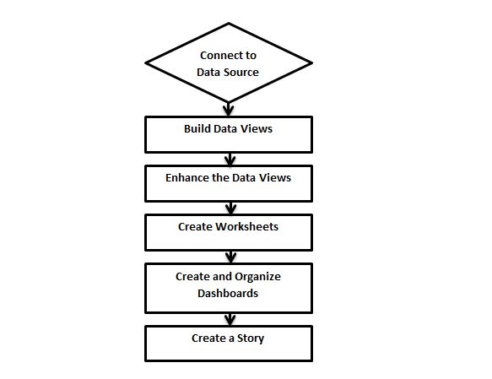

## Connect to Data Source (read data from sources – Excel, CSV, Oracle, MS SQL Server etc.)

-CSV: comma separate version

Tableau connects to all popular data sources. It has inbuilt connectors which take care of establishing the connection once the connection parameters are supplied. be it **Simple text files, Relational sources, No Sql sources or Cloud data bases**, tableau connects to nearly every data source.

## Build Data Views

After connecting to a data source, you get all the column and data available in the Tableau environment. You classify them as dimensions (text/non-calculative), measures (caculative/numeric) and create any hierarchy required. Using these you build views which are traditionally known as Reports. Tableau provides easy drag and drop feature to build views.

**Dimensions:** non-numeric column/non-calculated column example: Name, Address, Gender etc.

**Measures:** numeric column / calculated column

## Enhance the Views

The views created above needs to be enhanced further by use of filters, aggregations (function), Labeling of Axes, Formatting of colors and borders etc.

## Create Worksheets/Report (visualization of data)

We create different worksheets to create different views on the same data or different data.

## Create and Organize Dashboards (collection of worksheets)

Dashboards contain multiple worksheets which are linked it. So the action in any of the worksheet can change the result in the dashboard accordingly.

## Create a Story

A story is a sheet that contains a sequence of worksheets or dashboards that work together to convey information. You can create stories to show how facts are connected, provide context, demonstrate how decisions relate to outcomes, or simply make a compelling case

## ****Tableau Product Family****

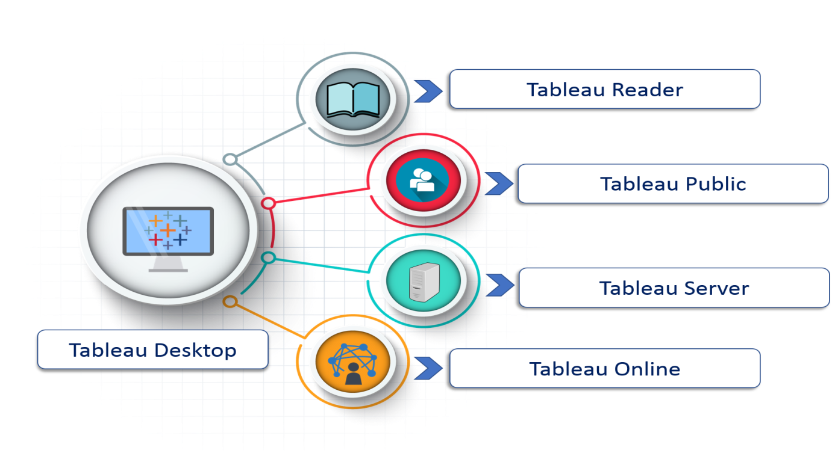

For clear understanding, data analytics in tableau can be classified into two section

1. **Developer Tools:** The Tableau tools that are used for development such as the creation of dashboards, charts, report generation, visualization fall into this category. The Tableau products, under this category, are the Tableau Desktop and the Tableau Public.
2. **Sharing Tools**: As the name suggests, the purpose of the tool is sharing the visualizations, reports, dashboards that were created using the developer tools. Products that fall into this category are Tableau Online, Server, and Reader.

Let's study all the products one by one.

### Tableau Desktop

Tableau Desktop has a rich feature set and allows you to code and customize reports. Right from creating the charts, reports, to blending them all together to form a dashboard, all the necessary work is created in Tableau Desktop.

For live data analysis, Tableau Desktop provides connectivity to Data Warehouse, as well as other various types of files. The workbooks and the dashboards created here can be either shared locally or publicly.

Based on the connectivity to the data sources and publishing option, Tableau Desktop is classified into

* **Tableau Desktop Personal:**The development features are similar to Tableau Desktop. Personal version keeps the workbook private, and the access is limited. The workbooks cannot be published online. Therefore, it should be distributed either Offline or in Tableau Public.
* **Tableau Desktop Professional:**It is pretty much similar to Tableau Desktop. The difference is that the work created in the Tableau Desktop can be published online or in Tableau Server. Also, in Professional version, there is full access to all sorts of the datatype. It is best suitable for those who wish to publish their work in Tableau Server.

### Tableau Public

It is Tableau version specially build for the cost-effective users. By the word "Public," it means that the workbooks created cannot be saved locally, in turn, it should be saved to the Tableau's public cloud which can be viewed and accessed by anyone.

There is no privacy to the files saved to the cloud since anyone can download and access the same. This version is the best for the individuals who want to learn Tableau and for the ones who want to share their data with the general public.

### Tableau Server

The software is specifically used to share the workbooks, visualizations that are created in the Tableau Desktop application across the organization. To share dashboards in the Tableau Server, you must first publish your work in the Tableau Desktop. Once the work has been uploaded to the server, it will be accessible only to the licensed users.

However, It's not necessary that the licensed users need to have the Tableau Server installed on their machine. They just require the login credentials with which they can check reports via a web browser. The security is high in Tableau server, and it is much suited for quick and effective sharing of data in an organization.

The admin of the organization will always have full control over the server. The hardware and the software are maintained by the organization.

### Tableau Online

As the name suggests, it is an online sharing tool of Tableau. Its functionalities are similar to Tableau Server, but the data is stored on servers hosted in the cloud which are maintained by the Tableau group.

There is no storage limit on the data that can be published in the Tableau Online. Tableau Online creates a direct link to over 40 data sources that are hosted in the cloud such as the MySQL, Hive, Amazon Aurora, Spark SQL and many more.

To publish, both Tableau Online and Server require the workbooks created by Tableau Desktop. Data that is streamed from the web applications say Google Analytics, Salesforce.com are also supported by Tableau Server and Tableau Online.

### Tableau Reader

Tableau Reader is a free tool which allows you to view the workbooks and visualizations created using Tableau Desktop or Tableau Public. The data can be filtered but editing and modifications are restricted. The security level is zero in Tableau Reader as anyone who gets the workbook can view it using Tableau Reader.

## Excel Vs. Tableau

Both Excel and Tableau are data analysis tools, but each tool has its unique approach to data exploration. However, the analysis in Tableau is more potent than excel.

Excel works with rows and columns in spreadsheets whereas Tableau enables in exploring excel data using its drag and drop feature. Tableau formats the data in Graphs, pictures that are easily understandable.

| **Parameters** | **Excel** | **Tableau** |
| --- | --- | --- |
| Purpose | Spreadsheet application used for manipulating the data. | Perfect visualization tool used for analysis. |
| Usage | Most suitable for statistical analysis of structured data. | Most suitable for quick and easy representation of big data which helps in resolving the big data issues. |
| Performance | Moderate speed with no option to quicken. | Moderate speed with options to optimize and enhance the progress of an operation. |
| Security | The inbuilt security feature is weak when compared to Tableau. The security update needs to be installed on a regular basis. | Extensive options to secure data without scripting. Security features like row level security and permission are inbuilt. |
| User Interface | To utilize excel to full potential, macro and visual basic scripting knowledge is required | The tool can be used without any coding knowledge. |
| Business need | Best for preparing on-off reports with small data | Best while working with big data. |
| Products | Bundled with MS Office tools | Comes with different versions such as the Tableau server, cloud, and desktop. |
| Integration | Excel integrates with around 60 applications | Tableaus integrated with over 250 applications |
| Real time data exploration | When you are working in excel, you need have an idea of where your data takes you to get to know the insights | In Tableaus, you are free to explore data without even knowing the answer that you want. With the in-built features like data blending and drill-down, you will be able to determine the variations and data patterns. |
| Easy Visualizations | When working in excel, we first manipulate the data that is present and then the visualization such as the different charts, graphs are created manually. To make the visualizations easily understandable, you should understand the features of excel well. | Whereas in Tableau, the data is visualized from the beginning. |